**Programming Questions – 3**

**Deadline: 05-Feb-2022**

1. Write a Program to display lower alphabet when uppercase corresponding alphabet is pressed from keyboard but the catch is there should be gap of 2 sec at max between pressing the button and displaying character, Use of ASCII values is not allowed neither built-in delay function.
2. A three digit number is called Armstrong number if sum of cube of its digit is equal to number itself.  
   E.g.- 153 is an Armstrong number because (13)+(53)+(33) = 153.  
   Write all Armstrong numbers between 100 to 1000, if the sum of all the Armstrong numbers between 100 and 1000 are greater than non-Armstrong numbers from 100-200 then write all Armstrong numbers from 100 to 1000 in Text File in sorted order ( No built-in function to be used for Sorting) else create an array and store the numbers in the array with their Ascii equivalent.
3. Write a program using structural and Object Oriented Approach to implement N-Queen Problem
4. Write a program to implement using classes && Aggregation or composition or association to implement document management system, every document is having multiple pages, every page is having multiple paragraphs, every paragraph is having multiple sentences, every sentence is having multiple words. You need to write a method which should return % of similarity between different documents.
5. Write a C / C++ Program to implement functionality of Guitar
6. Take an array of length n where all the numbers are nonnegative and unique. Find the element in the array possessing the highest value. Split the element into two parts where first part contains the next highest value in the array and second part hold the required additive entity to get the highest value. Print the array where the highest values get splitted into those two parts.  
   Sample input: 4 8 6 3 2  
   Sample output: 4 6 2 6 3 2

Store the output in the text file and make sure that there is no palindrome in the text file by comparing their Binary Equivalent.

1. Write a function “perfect()” that determines if parameter number is a **perfectnumber**. Use this function in a program that determines and prints all the perfect numbers between 1 and 1000.  
   [An integer number is said to be “perfect number” if its factors, including 1(but not the number itself), sum to the number. E.g., 6 is a perfect number because 6=1+2+3]. If total count of perfect numbers are more than total number of non-perfect numbers from 1 to 3000 then check that how many Vowels exists in every perfect number between 1 to 1000 and if there are more than 2-consecutive Vowels then swap the next 2-non-consective and store all such vowels in an array.
2. Write a program which should get 10 values from user and generate and display all possible combination either by addition or subtraction or multiplying or dividing of such values whose equivalent in Alphabet exists both in upper and lower case if there are values whose equivalent in Alphabet does not exists then add all those values and display those values from middle left, middle right, middle bottom and middle right of the screen and when values reach center of screen then values should splash off.
3. Given the Periodic table below, generate all possible combination of chemicals which are having atomic number greater than their immediate below chemical by difference of 15 to 20% at max, to the right the difference should not be more than 20% from that of immediately below and 10% at max from the difference from the left. All those chemicals should be displayed in sequence with increasing sum of atomic number of chemical created.

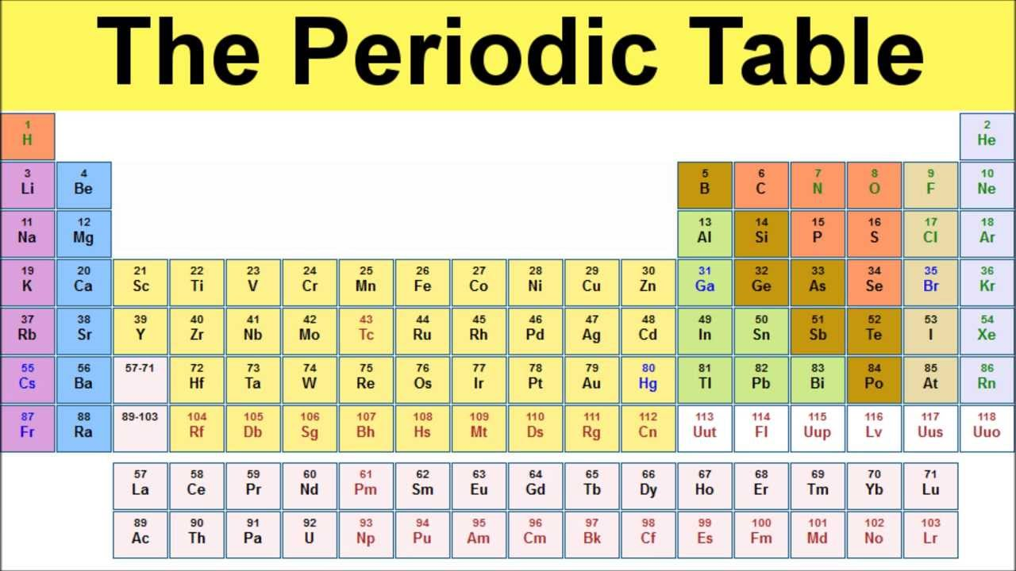

1. Write a Program which should read two files and should display the paragraphs which are having in common at least 3-sequence of consecutive characters having sum of characters more than 300 and difference should not be less than 30% of their sum.